**Hong Kong Institute of Vocational Education ( Tsing Yi )**

**Department of Information and Communications Technology**

**ITP4522 SPMQA**

**(2020/2021)**

**Assignment Scenario: Delivery Express System**

**Date: 4/19/2021**

|  |  |
| --- | --- |
| **Group member:** | **Signature:** |
| Tang Chun Hei  200022972 |  |
| Tsang Fu Yuen  200246734 |  |

1. **Fact Finding Results**

From the report of EDE company, we understand that they want to improve their current system and extend their business to different countries. Therefore , we are here to find out the possible solution that can reach the requirements.

In analysis and design phase, we will indicate the current needs and the new function that can improve current system. In this phase, we will analysis the current problem and then determine the solution that can update the system in order to provide more efficient functions that can help customer or staff to solve their needs.

**Background**

According to the planning phase we have mentioned, providing fast, reliable and door-to-door delivery service to customers is always the first priority of the company. Also, it want to extend the service to Toronto, New York, and London and providing a new import express service for the customer who needs regular supplies from aboard to Hong Kong. Also, some of the staff have mentioned that they want to have more function that can help them to manage the transaction, consolidate the data or even more access control to the database server. Therefore , we hope the new system can optimize the current system and bring tangible and intangible benefits to the company.

1. **Current problem and solution**

**Project background**

The requirement of EDE company is to improve the control of the staff. Allowing them to manage with the transaction easily. Besides, providing extra function for customer to place order or even track the shipment record.

|  |  |
| --- | --- |
| Current Problem | Solution |
| 1. It is time consuming for Express Centre Clerk to check customer’s document and then input the information . | An online form can let customer to fill in the bill information when they apply for the delivery service.  This can reduce the time consuming for checking whether the documents has filled the requirement information. |
| 1. **C**ustomer must have an account before booking the pickup service | Provide a online system for customer to register account. Without account it is hard to manage the order |

|  |  |
| --- | --- |
| 1. It is very high workload and time consuming for operation center staff to prepare for the shipment report and Pre-Alerting reminder to overseas Operation Centre colleagues. | System can help operation staffs to manage the shipment report and also can pre-alerting reminder to the oversea operation center colleagues automatically. |
| 1. Account Department takes a long time to follow with the customer documents, including the recipts , payment and invoice | Account department can track the payment status by the orderID. They can sort the payment by paid or haven’t pay |

|  |  |
| --- | --- |
| 1. The Customer Service staff thinks they don’t have sufficient information to answer customer queries that is relate to the shipment | CS staff can get the shipment record from the server and then display to the customer |
| 1. The computer systems in different offices and centers are independent systems and they are not integrated with each other. Data is transferd by email. | A new server should be purchased for the installation of the database server and application server. To increase system security, all the staff should have their accounts to manage and log their records and tasks. |
| The Managing Director prefers to have more reports for analysis and management control | Managing Director can ask AI to parse the reports from the database server |

1. **Functional Requirement**

**3.1 New Server**

**P**rovide a new server to connect the data together as member personal computers are not interconnected. First Hosting an application server that can record the application of the user and then host a database server that can receive the application data from the application server. Therefore all the staff can share the data from the database server even the computers are not interconnected. Staff can log in to the database server to request the data. Besides, there should be a back-up server to store the data to prevent server down situation.

* Staff Account
* Password

**3.2 Artificial Intelligence**

**M**anaging director can use the server to manage the data and combine them together. There will be an artificial intelligence to help managers to analyze the transaction and manage them with different express type and order. And of course, the artificial intelligence has to be tested before implementing into the system. And once the testing is finished, the Managing director can use the artificial intelligence to analyze the transaction of different area or country. And the manager has to log in to their Managing director account in order to get the data from the artificial intelligence. Also, the Managing director can request the artificial intelligence to calculate different statistic of the transaction to check about the profits in a different area.

**A**ccounting clerks can activate the artificial intelligence receive function by their Accounting clerk account. Once the artificial intelligence activated, the express information will automatically receive to the Accounting clerks account. If there are too many express information to handle, accounting clerks can stop the artificial intelligence received function. When the account clerks finish their duty, they can activate again. And finally, after the data has been consolidated, Accounting clerks can send back the data to the database for storing.

**3.3 Create Website**

**3.3.1 User can register account on the website**

Basic Account

**O**n the website, users can create an account with their email address or phone number. Besides, users have to provide their personal ID for further verification that can prevent fake accounts or orders. Once they submit their application, it will automatically send to the database server for the system to verify. And after verification, it will send back the verification code to the email account or phone account for them to activate. If the user does not receive the verification code, they can request the website to send a new verification code again. Once the user enters the correct verification code and submits it. The account will be created and the screen will navigate to the website main page and show up some tips to guide the user basic function.

The required attributes are:

* Email / Phone number
* Password
* PersonalID

Company Account

**U**ser can register a company account with their company. The company account is mainly focused on the bulk delivery order. User can place a bulk delivery order with their registered company account. To create a company account, the user application should include company proof. After the application sent to the server database and the staff confirm the company exist and the proof is real, the system will send the approval code to the email or phone to tell the user that the company account has been verified.

* Email / Phone number
* Password
* CompanyName
* CompanyProof

**3.3.2 Problem Query**

**U**sers can use the chat room function to query their question. And after they send the message in the chat room, AI will respond to their question according to the keyword that the user has asked. If the question belongs to the type that AI cannot respond to, AI will send a message to the system to request a customer service officer to answer the queries. And after a moment, a customer service officer will appear in the chat room and answer the question.

**3.3.3 User delivery order**

**U**ser can query the delivery expense on the website. There will be an online calculation function for users to calculate their delivery expense quickly. User can enter the information of the express. If the package of the express is larger than the standard example of the package, the user can input the height, width, length to calculate the extra expense of the express.

* ExpressType
* DeliveryType
* OriginatingPlace
* DestinationPlace
* ExpressWeight
* Height(Optional)
* Length(Optional)
* Width(Optional)

**U**sers can enter their information to place the order . Once they send the application to the server, it will calculate the total expense and show it to the user with the OrderID. User can reserve the order for a week. After a week, if the order payment has not to be done, the order will be deleted by the server automatically.

**Sender**

* Name
* Region
* Address
* Contact

**Receiver**

* Name
* Region
* Address
* Contact

**Express information**

* PickUpDate
* ExpressType
* ExpressWeight
* Height
* Length
* Width

**3.4 Payment Method**

**3.4.1 Credit Card**

**I**f the user chooses credit card payment, the user can log in to his or her account to use the credit card that has connected with the account to pay. If the user does not have an account, the system will request the user to input their card number, expiry date and type. And the system will send the card information and amount charged to the external gateway. Once the transaction is approved. The approved code will be sent back to the user. If the transaction not approved, the system will ask the user to reselect the payment method again.

**3.4.2 Account Balance**

**F**or the second payment method, the user can use their account balance to pay the express expense. If the user account has a sufficient balance, the system will charge the amount to their account. If the account does not have a sufficient balance, the system will ask the user to reselect the payment method. And finally, after the user pays the amount successfully, the delivery order will be approved and started. If the user does not have an account, the system will ask them to register an account or choose other payment methods.

**3.4.3 Cash**

**U**sers can pay their payment with cash at the EDE center by providing the Order that has been placed. Once the user has paid the amount at the EDE center, the center staff will approve the user’s order and send it to the system for other staff to handle.

**3.4.4 Cheque**

**U**ser can choose a cheque to pay the payment. User can send the cheque to any center address and once the center receives the cheque. Staff will help the user to handle the order immediately. If the user does not have a registered account, the user can go to the EDE center to pay the cheque and the same as cash payment the counter staff will approve the order for the user.

**3.5 Pre-alerting system**

**T**he system can remind both sender and receiver about the pick-up date and the delivery date by the order provided contact. The system will send a message to the provided contact a day before the pick-up or delivery date. Also if the user has a registered account. the system will send the delivery message to the account too.

**3.6 Track the Shipment**

**U**ser can track their shipment by login into their account. There will be a function call shipment tracking on the website. User can input their OrderID of the order to request the information. Once the system received the application, the database server will return the details of the order. If the OrderID provided not existed, the system will ask the user to input the correct OrderID or pay the delivery expense before tracking the shipment.

* OrderID

**3.7 Monthly Shipment Record**

**U**sers can check their monthly record by login into their account. There will be a shipment record button on the website for users to click and check the details of their monthly shipment. User can sort the shipment record by the date, amount, area, invoiceID.

**Non-Functional Requirement**

**4.1 Usability**

**S**ince there are many different items associated with the company, the system has to provide a user-friendly interface for the members to use. Especially the filter and sorting function for the staff to easily query the information they need. Besides, staff can follow the instruction video to learn how to use the software commands, such as searching function, requesting data. Also, Staff can click the tips button to get more instruction if they want to know more functionally about the UI.

**4.2 Operational**

**Logging**

**A** logging function is a must on any inter and outer system. It can protect company interests by logging with different types of accounts. And the user interface will also be different such as a normal customer account will not see any customer managing the user interface. And the system also needs a log to keep the recent logging records for preventing hackers and protecting customer’s interests.

**Availability**

**S**ince the original system needed Customer Service 24-hour stand by to respond to all the customer’s questions. The new system will become an AI Customer Service auto-respond to almost all the simple questions such as auto send an email to customer announce him/her the package shipping status. Also, it can reduce the workload and a lot of cost for hiring 2 staff for morning and night.

**4.3 Data Storing**

**U**nlike traditional data storage, it doesn't need a huge space to store paper data. All the data will now be stored on a server. If you want to search for some data at any time, you can quickly request the data from the database server to save time and manpower.

**4.4 Security**

**T**o prevent unnecessary misunderstanding, it is important to create a safe and secure server for the customer. Log files will be provided to store the error of the server and prevent suspicious login by checking the logging log files.

**Access control**

**D**ifferent staff will have different permission to access the system. The system allows the following permission:

* Customer can create new pickup and shipping collection order
* Customer can read the product list
* Customer can read his/her delivery records
* Customer can write his/her account information
* Delivery staff can read the delivery information
* Delivery staff can read and update delivery note
* Managing director can use artificial intelligence to analyze the transaction information
* Managing director can manage the customer accounts
* Managing director can manage the delivery note
* Managing director can read the customer information
* Accounting Clerk can collect express information
* Accounting Clerk can read delivery records
* Customer Service Officer can read/write customers data
* Customer Service Officer can read/write delivery note

**4.5 Compatibility**

**S**oftware compatibility is a characteristic of software components or systems that can operate satisfactorily together on the same computer or different computers linked by a computer network. Also, the data in the new system will allow the old system to import the data that was stored in excel.

**4.6 Performances**

**T**he system will provide a stable response time to the user. We believe this system is a quick and reliable system that can transfer data to different offices in few seconds. Also, the application from the website to the database will be less than five seconds in order to provide fast and convenient service to the customer.

**4.7 Reliability**

**T**he system must be tested to prevent any exception. For example, if the system suddenly shuts down, the application or database server will lose connection which will affect the operation of the system. Therefore, to prevent the system from suddenly down, providing maintenance service is also a must for further protection. Hence, a backup server should be provided to be more reliable.

1. **Current and proposed system**

**Current system:**

**Server**

* The system is independent between different offices can centers

**Staff**

* The Managing Director prefers to have more reports for analysis and management control
* It is high pressure for accounting department to receive the express information from Express Centers and to consolidate the datafor record keeping.
* Express Centre clerk has to manually input the Airway Bills to the electronic spreadsheets
* Shipping clerk has to manually printing shipment reports for chief operations manager
* Customer service staff thinks they are not capable to answer customer inquiries which is mainly about the shipment status.

**Customer**

* Customer has to call 24-hour customer service hotline to register account.
* Customer has to call 24-hour customer service hotline to track their shipments
* Customer can’t use cheque to pay if he or she doesn’t has an account
* Customer’s bill or invoice require some time to send to EDE
* Customer can not book a pickup order if he or she doesn’t has an account.

**Proposed system:**

**Server**

* A database server for the not inter-connected PCs to share their data to the server, and different operation center staffs can request it from the server.
* An application server for the customer and staff to apply their requirement
* Backup system to prevent data loss

**Staff**

* managing director can request more reports from the server with AI helping
* Accounting department can consolidate the data to the database server with AI helping
* Shipping clerks can inform receiver automatically
* Shipping clerks can manage the report with AI helping
* Customer service can answer customer inquiries with AI helping

**Customer**

* Customer can register an account with the website
* Customer can book a pickup arrangement of shipping collection with their account
* Customer can calculate the shipping expenses on the website
* Customer can track the shipment by providing their shipmentID on the website
* Customer’s bill or invoice can send to the server immediately

**A**fter comparison, the proposed system can bring out more benefits to staff, company and customers than the original one and which provide convenient function for them to do the control.

Customer can place order or do other controls on the website which is fast and reliable.But current system has to take longer time and effort to take the action. And that is how the proposed system can bring a better service to the customer.

Staff can share data in the database server even they are standalone PCs, Also, they can use AI to help them handle some complicate and bore workload. The expected output is that the proposed system can reduce the workload and increase the efficiency compare to the current system.

And for the company, a new system can bring a new positive image that can promote the the company. Improving the system can let customer understand that EDE care about their opinion which can enhance company reputation. Therefore, the proposed system will be more reliable to the customer and earn their trust.

1. **Detailed Design of System**

**Use case diagram**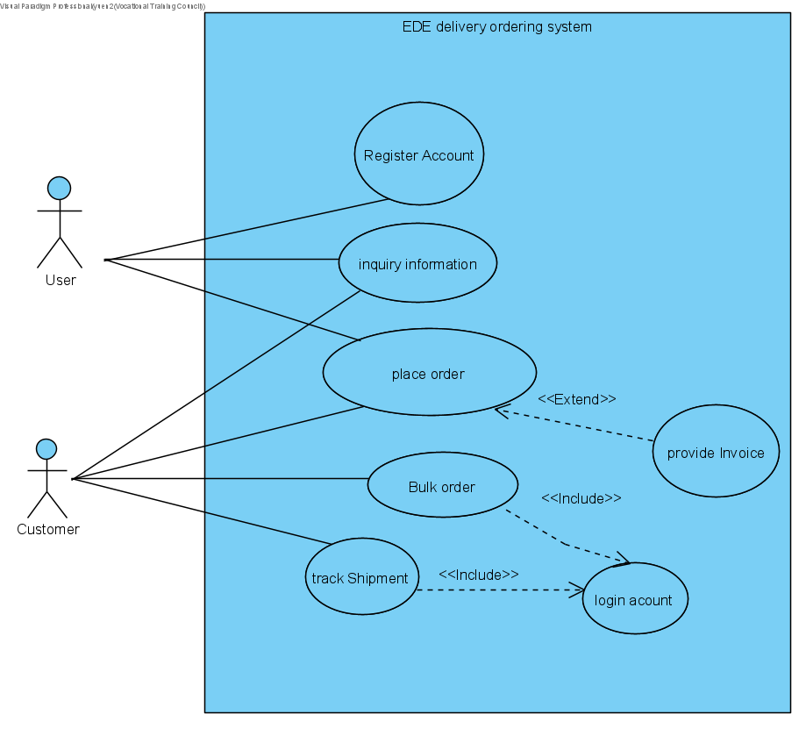

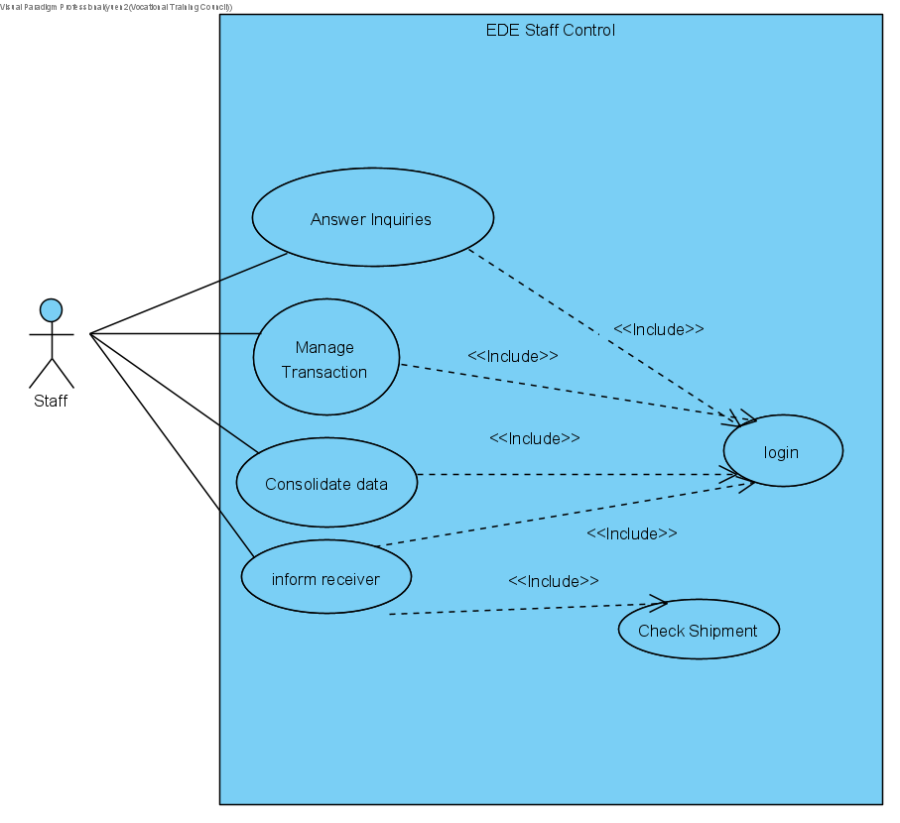

**Functions list**

* Customer can register account on the website
* Customer can place order on the website
* Customer can place bulk order on the website with an account.
* Customer can inquiry information
* Customer can track the shipment with an account.
* Customer service staff can answer customer inquiries with the AI
* Shipping agents can handle the shipping report with the AI
* Shipping agents can automatically inform the receiver about the delivery with the system
* Managing director can ask AI to get more transaction to analysis from the database server.
* Accounting clerk can consolidate the data to a common server

**ER diagram/ Class diagram**

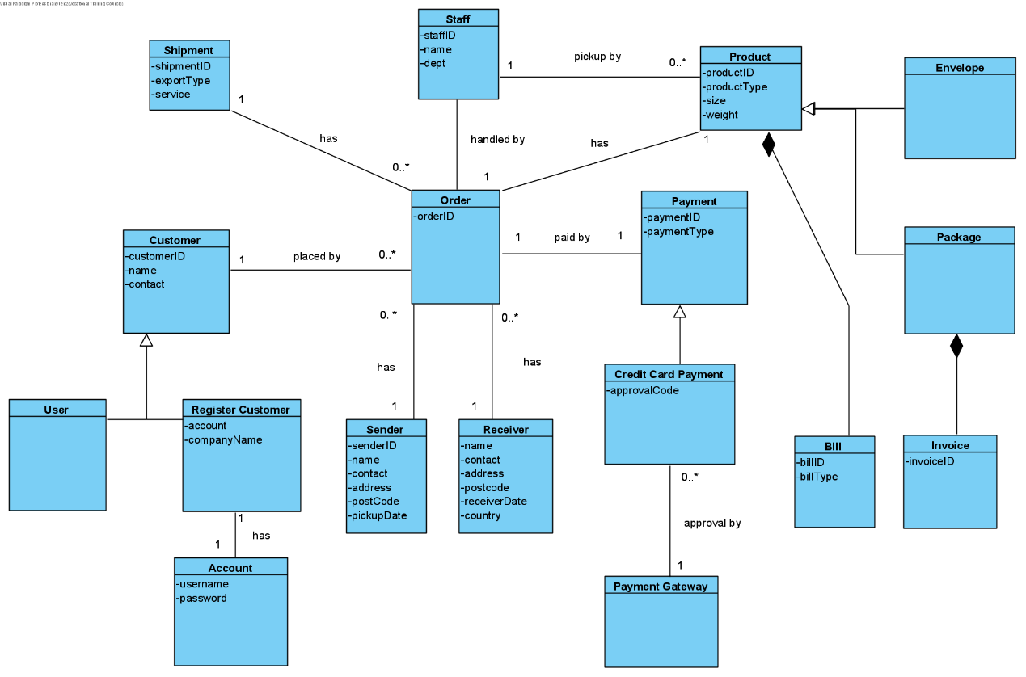

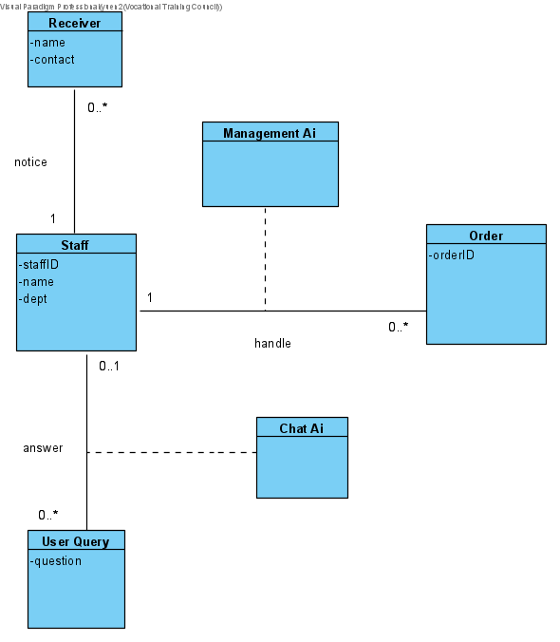

1. **Structure Chart**

**Hardware Architecture**

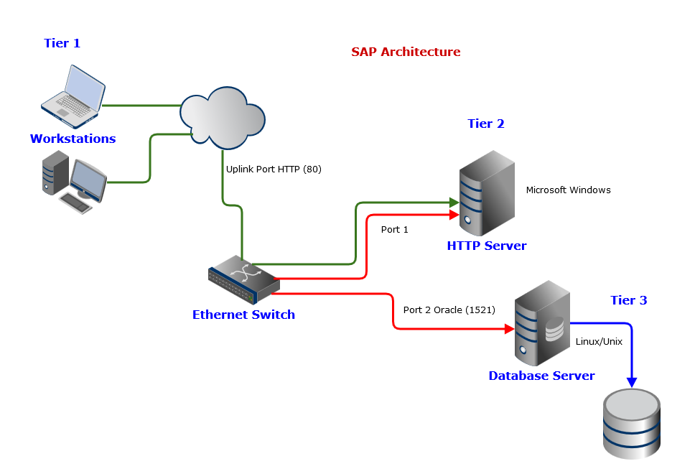

**Software Architecture**

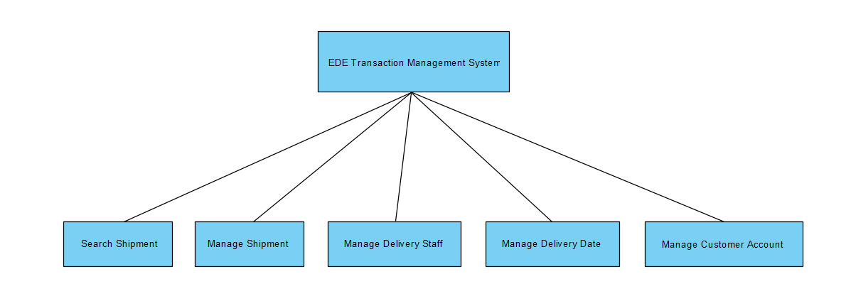

1. **User Interface Design**

**Staff Login UI**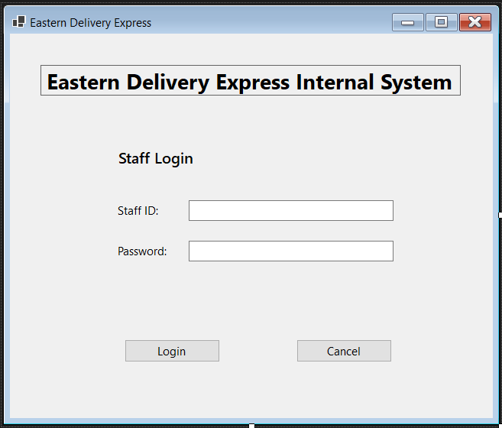

**A simple internal login UI. If the password has been forgetting, they need to contact the IT department to change the password.**

**Staff Management UI**

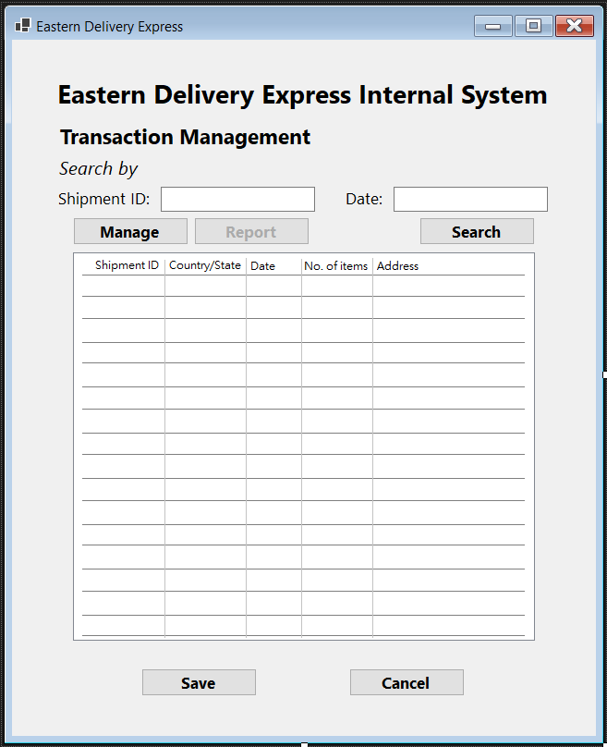

**(Normal staff account views)**

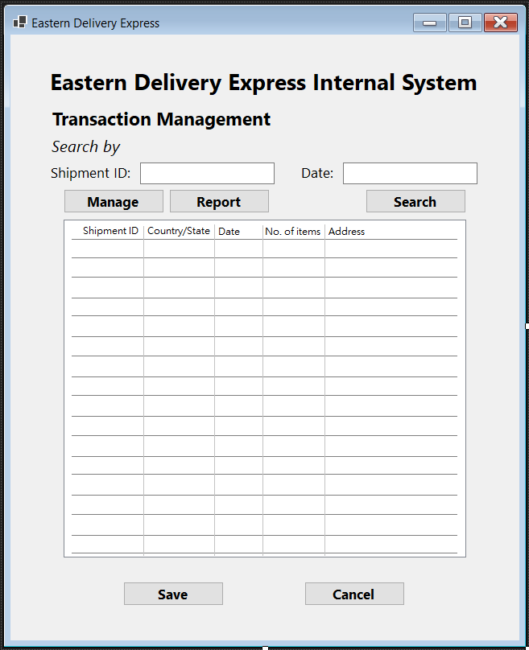

**(Finance staff and Managers views)**

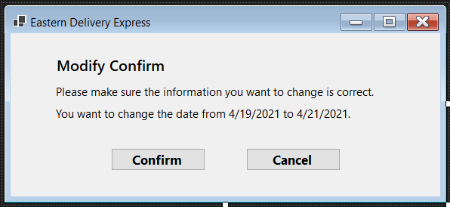

**(Modify Confirm)**

**The staff can search the shipment by inputting the shipment ID or date to find the specific one or the whole day transaction. To prevent unnecessary edit by miss clicking. We create a ‘manage’ button for the staff. When they have to modify some information, they need to click the manage button first and select the cell they want to change. And normal staff account will not able to click the report button. This button is only for finance staff or managers.**

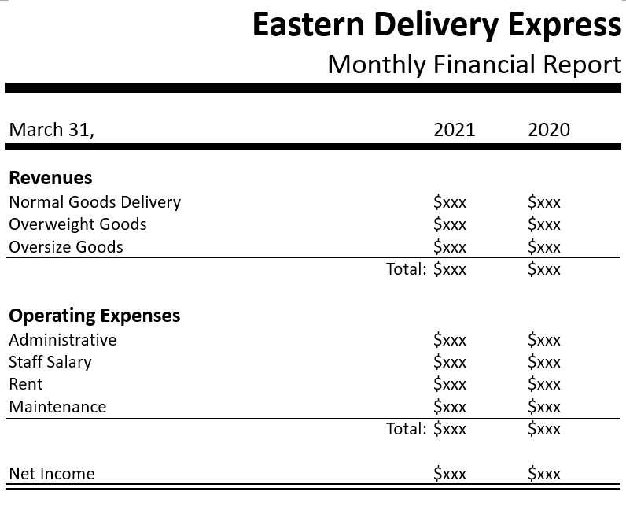

**(Monthly Report)**

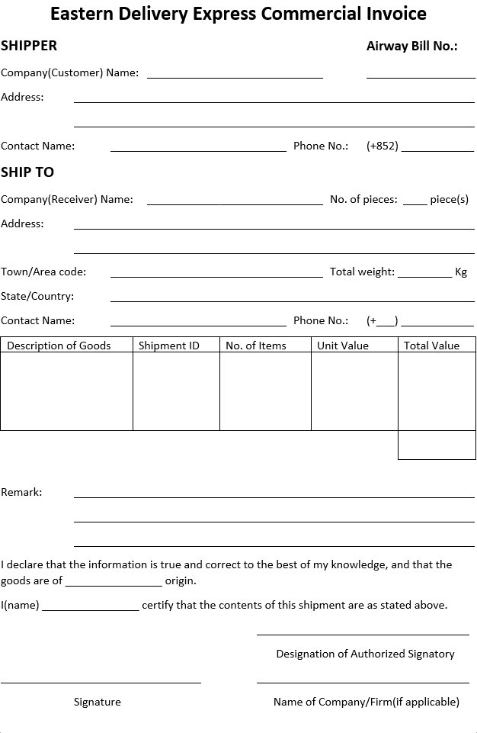

**(Invoice)**

**Web Login UI**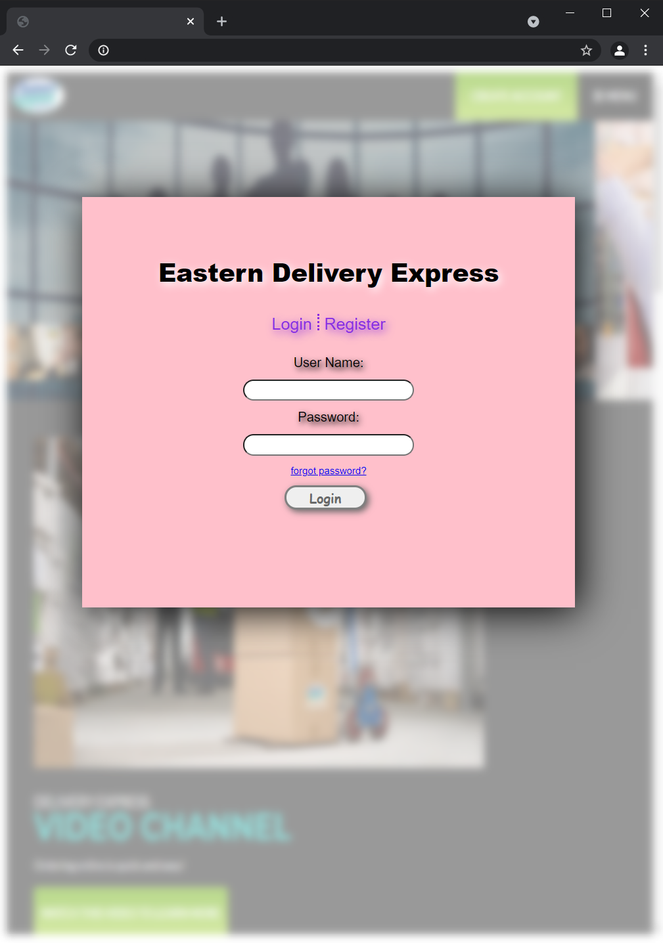

**A common web page login UI. Input user name and password to login. User can change the password by clicking the forgot password and receive password changing email.**

**Web Order UI**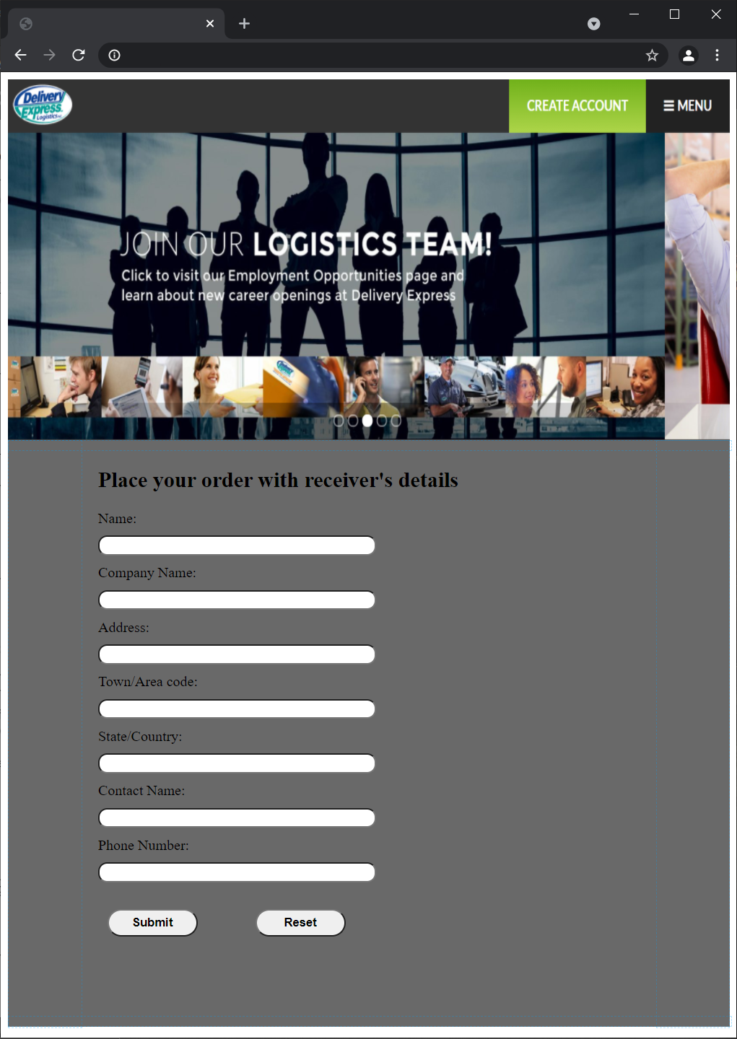

**Placing an order by input the details of receiver. Company will transfer the information to pickup staff. Then, they will meet the customer calculate the number of item and measure the total weight to print a simple invoice for customer.**

**Web AI Customer Service UI**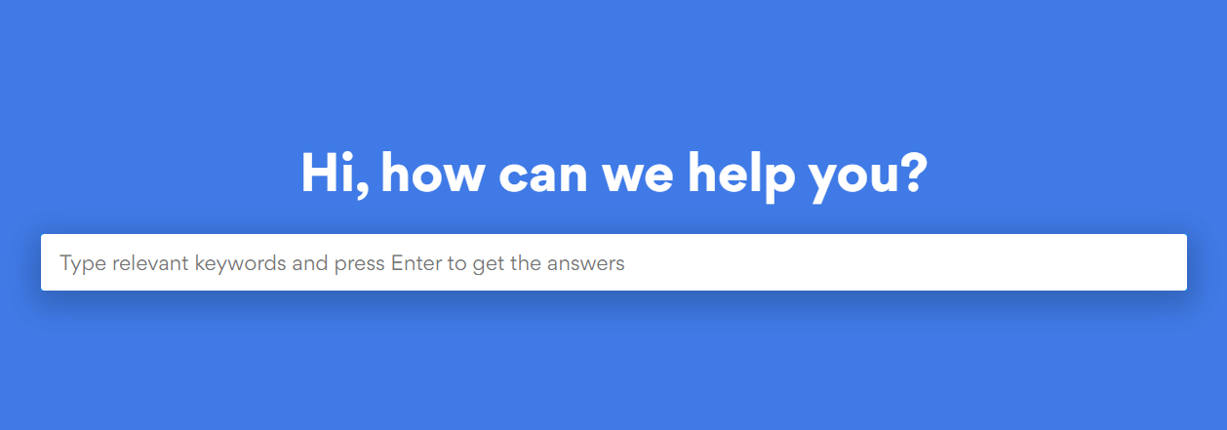

**The web AI will deal with most of the simple question such as how to change password, how to place an order. The complicate question will pass to customer service manager.**

1. **Process design**

**Use case description**

**Customer Use Case**

|  |  |
| --- | --- |
| **Use case name:** | Register Account |
| **Use case ID:** | UC-100 |
| **Primary actor:** | User |
| **Brief description:** | User can register account on the website |
| **Preconditions:** | The user browse the website and click the registration button |
| **Flow of events:** | User click the registration button  1. User enter the required information and submit to the server 2. User wait for the server send the validation code and then validate the account with their email |

|  |  |
| --- | --- |
| **Use case name:** | Inquiry information |
| **Use case ID:** | UC-200 |
| **Primary actor:** | User, Customer |
| **Brief description:** | User or customer can inquiry delivery information on the website |
| **Preconditions:** | The user browse the website |
| **Flow of events:** | 1. User or customer can chat with the bot ai to inquiry information 2. If some of the inquiries AI can not answer, ai will ask for CS staff to answer the user or customer question |

|  |  |
| --- | --- |
| **Use case name:** | Place order |
| **Use case ID:** | UC-300 |
| **Primary actor:** | User,Customer |
| **Brief description:** | User or customer can place order with the system |
| **Preconditions:** | The user browse the website |
| **Flow of events:** | 1. User or customer enter the required information to place the order 2. After the validation,system will send back the orderID for customer or user to confirm the order. |

|  |  |
| --- | --- |
| **Use case name:** | Place bulk order |
| **Use case ID:** | UC-400 |
| **Primary actor:** | Customer |
| **Brief description:** | Customer can place bulk order with discount |
| **Preconditions:** | Customer must have an account and provide the company information |
| **Flow of events:** | 1. Customer login and enter the required information toplace the bulk order 2. After the validation,system will send back the orderID for customer or user to confirm the order. |

|  |  |
| --- | --- |
| **Use case name:** | Track shipment |
| **Use case ID:** | UC-500 |
| **Primary actor:** | Customer |
| **Brief description:** | User can track the status of their order |
| **Preconditions:** | The customer must have an account |
| **Flow of events:** | 1. Customer login their account 2. Click the status of shipment and all of the order placed by customer will shown on the screen |

**Staff Use Case**

|  |  |
| --- | --- |
| **Use case name:** | Inform receiver |
| **Use case ID:** | UC-600 |
| **Primary actor:** | Staff (Shipping clerk) |
| **Brief description:** | When the delivery is ready,shipping clerk reminds the receiver about the delivery date |
| **Preconditions:** | The packge or envelope arrive destination place successfully |
| **Flow of events:** | 1. Shipping Clerk remind the receiver that the delivery is ready. 2. Receiver confirm the delivery and the delivery staff will delivery the product accoring to the date. |

|  |  |
| --- | --- |
| **Use case name:** | Manage transaction |
| **Use case ID:** | UC-700 |
| **Primary actor:** | Staff (Managing Director) |
| **Brief description:** | Managing director can use ai to help him or her to manage the large amount of transaction |
| **Preconditions:** | The manager login their account |
| **Flow of events:** | 1. Active the ai to sort the transaction 2. Ai send back the managed transaction to manager |

|  |  |
| --- | --- |
| **Use case name:** | Answer inquiries |
| **Use case ID:** | UC-800 |
| **Primary actor:** | Staff (CS Officer) |
| **Brief description:** | CS Office can answer the customer inquiries with the system |
| **Preconditions:** | The CS Officer is onlining |
| **Flow of events:** | 1. AI tells CS Officer that they can’t solve the question 2. AI send the chat room link to CS Officier 3. CS Officier go to the chat room and answer the customer inquiries |

|  |  |
| --- | --- |
| **Use case name:** | Consolidate data |
| **Use case ID:** | UC-900 |
| **Primary actor:** | Staff (Accounting Clerk) |
| **Brief description:** | Accounting Clerk can cosolidate the data and manage it easily by the system |
| **Preconditions:** | The Account Clerk login their account |
| **Flow of events:** | 1. Account clerk ask for consolidate data 2. Ai finish consolidate and send back the data location access code |

**Workflow diagram**

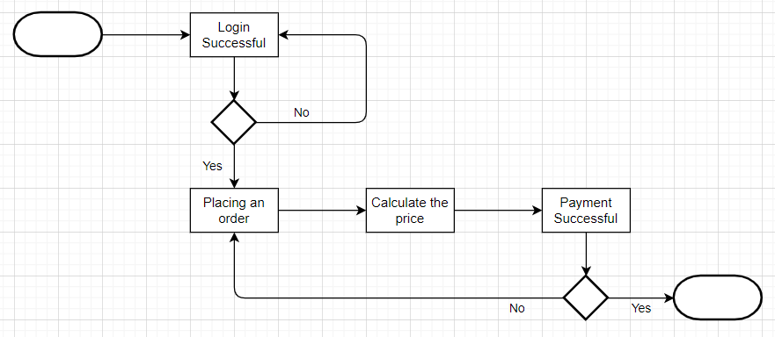

1. **Test Plan**

**T**here will be some section to be tested during the test phase for EDE company. First, test the web interface whether it can connect with the server. For example, testing the website registration, login, place order, etc.

**10.1 Unit testing**

**B**ecause of web interface and system management are developed directly from the program specification, we don’t have to look deeper what the source code are. Therefore, it will be using black-box testing. However, for the system interface , we must make sure the logic and the code won’t mess up , so it will be using white-box testing.

**10.2 Integration testing**

**F**or integration testing, we have to make sure that the web interface and system management whether their user interface, user scenarios and data flow can work properly. And make sure the system interface can run without errors.

**10.3 System Tests**

**I**n system test, it is used to make sure all the part of the system can meet the requirement, such as the business requirement. Testing the security of all system in order to provide a reliable and safe system. Also, testing the usability of the web interface to make sure it is user friendly and easy to use. The response time of the system management will be test also.

**10.4 Acceptance Tests**

**T**here will be two stages for testing. The first one is the alpha testing which will be using some made-up data and the second one is the beta testing which will use the real data

|  |  |  |  |
| --- | --- | --- | --- |
|  | Web interface | System Management | System interface |
| Unit tests | Black-box tests | Black-box tests | White-box tests |
| Integration tests | User interface Use scenario test | User interface tests  Use scenario test | System interface tests |
| System tests | Requirement tests  Security tests  Performance tests  Usability test | Requirements tests  Security tests | Requirements tests  Security tests  Performance tests |
| Acceptance tests | Alpha test  Beta test | Beta test | Alpha test  Beta test |

1. **Test Cases**

**Web Login**

|  |  |  |  |
| --- | --- | --- | --- |
| Test Case | Pre-condition | Test Steps | Test Result |
| Verify login information with correct username and password | User have an account | 1. Navigate to the login page  2. Enter username  3. Enter password  4. Click the login button | 1. user navigate to the login page  2. user can input their username  3. user can enter their password  4. user login success and navigate to home page |
| Verify login information with incorrect username | User have an account | 1. Navigate to the login page  2. Enter username  3. Enter password  4. Click the login button | 1. user navigate to the login page  2. user can input their username  3. user can enter their password  4. error message to alert user wrong username |
| Verify login information with correct username and incorrect password | User have an account | 1. Navigate to the login page  2. Enter username  3. Enter password  4. Click the login button | 1. user navigate to the login page  2. user can input their username  3. user can enter their password  4. error message to alert user wrong password |

**Staff control**

|  |  |  |  |
| --- | --- | --- | --- |
| Test Case | Pre-condition | Test Steps | Test Result |
| Accounting clerk transfer consolidated data to database server | Login AC account | 1. Click the interface that is upload data to database server  2. click the upload button and wait for it process | 1. Navigate to the upload interface success 2. Pop out data upload success and return the data location code |
| Accounting clerk transfer consolidated data to database server | Login AC account | 1. Click the interface that is upload data to database server  2. click the upload button and wait for it process | 1. Navigate to the upload interface success 2. Pop out data upload fail |

|  |  |  |  |
| --- | --- | --- | --- |
| Test Case | Pre-condition | Test Steps | Test Result |
| Managing director request more report | Login managing director account | 1. Click the report interface  2. activate AI to get report | 1. Navigate to the report interface success 2. AI keeps sending the report from database to the director |
| Managing director request more report | Login managing director account | 1. Click the report interface  2. activate AI to get report | 1. Navigate to the report interface success 2. AI can not recognize the report in database and pop out error message |

1. **Migration**

**F**or the migration plan, it include decisions, plans, and procedures.

**T**he conversion strategy style will be using parallel conversion as it can let the old system and new system co-exist for a period of time. And this can prevent system sudden down and the data lost when it compare to direct conversion. Although It will increase the cost when running both system simultaneously and time consuming, it can count as the insurance of the system. Once the system down, all the data will be lost. Therefore , it is important to use parallel conversion as EDE is a large scale company.

**F**or the conversion location, phased conversion will be used as it can converse the system phase by phase. And it can provide training for the staff using the new control phase by phased without pressing burden on the help desk personnel.

**A**nd for the conversion module, modular conversion will be the best option as it can reduce the risk and it is the important factor when doing the migration.

**I**n this situation, risk is high priority than time and cost as there are lots of data in the old system. If the old one is down, it will bring unexpected lost to the company. And for the time, there are not urgent needs in the company, so it can prevent the risks occur when rushing the migration of the system. For the cost, it is important factor to consider when doing the migration, but we believe that it is worth to ensure the risk with high cost . Therefore , we prioritize risk in the migration.

1. **System support arrangement**

**P**roviding training session for the staff to get used to the new system function. For example , teaching account clerks how to request data from the database server and then consolidate them. Also, there will be the instruction videos to talk about the new function detailly.

**13.1 Maintenance**

**I**f there any errors or some function that is not work as expectation, staff can leave the comment on the comment session to let us know what can we do to improve the system in order to optimize it. Once if there are too many request about new function, we will pass the requirement to the committee to discuss about the feasibility , cost and benefits. Once we receive the approval message, we will pass the new request to the analysist to design how to implement the new requirement in the current system in order to help the staffs to minimize the workload.

1. **Conclusion**

Last but not least, we have identified the plan, analyze, design and implement this 4 phases and hope that those can help us to develop the new system, upgrading the current issues of the system and the customer service in order to bring out more benefits to the company.